**DAILY ONLINE ACTIVITIES SUMMARY**

|  |  |  |  |  |  |  |  |
| --- | --- | --- | --- | --- | --- | --- | --- |
| **Date:** | **22/06/2020** | | | | **Name:** | **Syed Rabeya Aamir** | |
| **Sem & Sec** | **8th B** | | | | **USN:** | **4AL16CS112** | |
| Online Test Summary | | | | | | | |
| **Subject** | | **SMS** | | | | | |
| **Max. Marks** | | **30** | | **Score** | | **---** | |
| Certification Course Summary | | | | | | | |
| **Course** | **Exam Readiness: AWS Certified Solutions Architect – Associate (Digital).** | | | | | | |
| **Certificate Provider** | | | **Aws** | **Duration** | | | **2 hrs** |
| Coding Challenges | | | | | | | |
| **Problem Statement:**  **1)** Python program to split array and move first part to end. | | | | | | | |
| **Status: Solved** | | | | | | | |
| **Uploaded the report in Github** | | | | **YES** | | | |
| **If yes Repository name** | | | | **rabeya** | | | |
| **Uploaded the report in slack** | | | | **YES** | | | |

**Certification Course Details:**

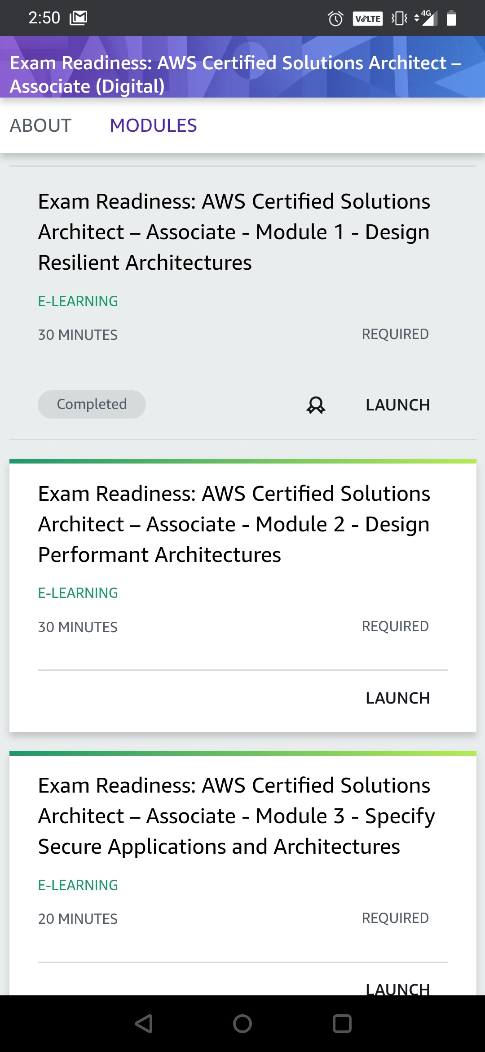

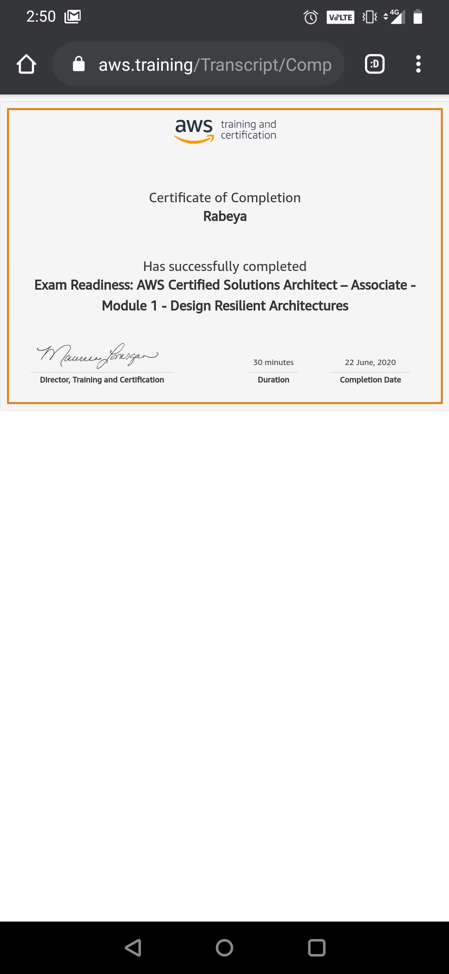

# CODE:

Program no:1

# Python program to split array and move first part to end.

def splitArr(arr, n, k):

for i in range(0, k):

x = arr[0]

for j in range(0, n-1):

arr[j] = arr[j + 1]

arr[n-1] = x

# main

arr = [12, 10, 5, 6, 52, 36]

n = len(arr)

position = 2

splitArr(arr, n, position)

for i in range(0, n):

print(arr[i], end = ' ')